Exercise # 1
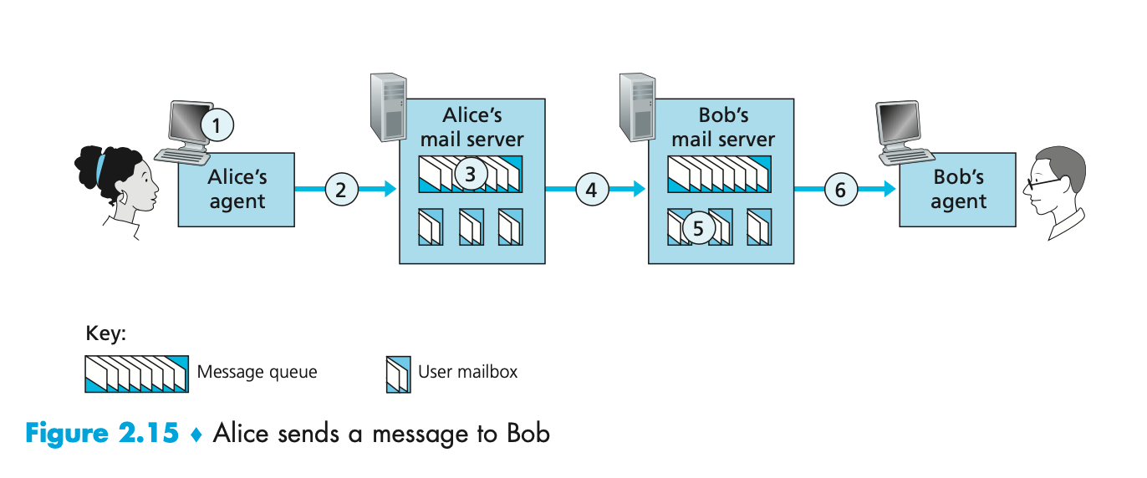

QUESTION LIST

1. At point 2 in the diagram, what protocol is being used?
2. At point 4 in the diagram, what protocol is being used?
3. At point 6 in the diagram, what protocol is being used?
4. Does SMTP use TCP or UDP?
5. Is SMTP a 'push' or 'pull' protocol?
6. Is POP3 a 'push' or 'pull' protocol?
7. What port does SMTP use?
8. What port does POP3 use?

1. At point 2 in the diagram, the SMTP protocol is used.
2. At point 4 in the diagram, the SMTP protocol is used.
3. At point 6 in the diagram, the HTTP protocol is used.
4. SMTP uses the TCP protocol.
5. SMTP is a 'push' protocol
6. HTTP is a 'pull' protocol
7. SMTP uses port 25
8. HTTP uses port 80

Exercise #2
Consider an HTTP server and client as shown in the figure below. Suppose that the RTT delay between the client and server is 20 msecs; the time a server needs to transmit an object into its outgoing link is 0.75 msecs; and any other HTTP message not containing an object has a negligible (zero) transmission time. Suppose the client again makes 100 requests, one after the other, waiting for a reply to a request before sending the next request.
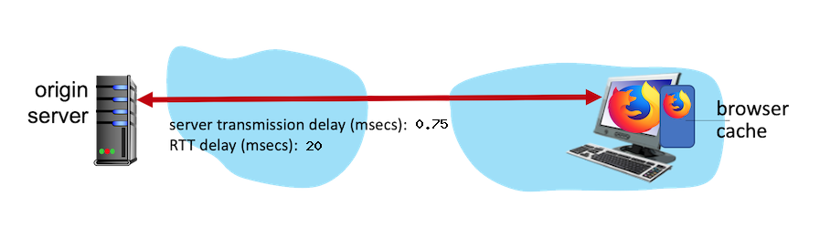

Assume the client is using HTTP 1.1 and the IF-MODIFIED-SINCE header line. Assume 50% of the objects requested have NOT changed since the client downloaded them (before these 100 downloads are performed)

QUESTION

1. How much time elapses (in milliseconds) between the client transmitting the first request, and the completion of the last request?

(RTT * NUM_PACKETS) + (NUM_PACKETS * (PERCENT__NOT_CACHED / 100) * TRANS_DELAY)

